Advancements in Computational Fluid Dynamics for Rotor Applications

Increasingly the sophistication of rotorcraft flow simulation has become more complex as it involves environments such as: (a) helicopter landing on a ship deck, (b) formation flight of multiple vehicles, (c) brownout conditions of a helicopter landing on loose or sandy soil. These problems involve solution of Navier-Stokes equations on various grid types (structured, unstructured or hybrid). The key to obtaining an engineering solution to the complex physics that dictates these multi-dimensional class of problems is to employ one more of the following techniques: (a) Higher order schemes, (b) Complex algorithms that exploit the physics intelligently, (c) Multigrid , (d) Parallel Processing and (e) geometry and automation. This presentation will focus on the development of a physics based new algorithms for rotorcraft applications that show considerable promise for computational efficiency.
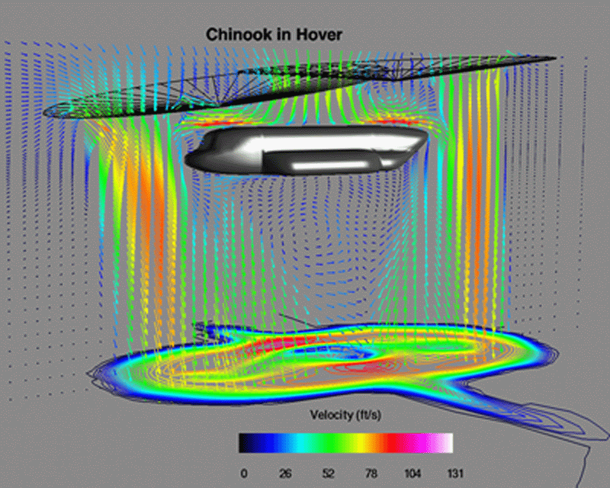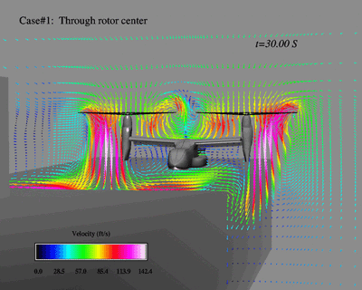
The SIMPLE family of algorithms have popularized the pressure based schemes for incompressible flows. The effect of pressure on velocity is of primary importance in incompressible flows. However, pressure appears only as a source term in the momentum equations. The continuity equation implicitly dictates the pressure field and yet pressure is not a variable of the mass conservation equation. This predicament and its remedy well known by the name pressure velocity coupling is resolved in SIMPLE and its variants (SIMPLER, SIMPLEC) by obtaining an approximate pressure correction field which is used iteratively to correct the velocity field and/or the pressure field seeking an overall satisfaction of the conservation equations. The approximate nature of the pressure correction equation is often attributed to convergence issues. The new algorithm presented here is based on the fact that, if the pressure field is known the momentum equations can be solved iteratively or otherwise to obtain the velocity field correctly. An exact equation for the pressure field is obtained by manipulating the discretized mass and momentum equations. Once the pressure field is known the velocity is updated explicitly using the four stage Runge-Kutta algorithm without the need for iterating the momentum equations. Representative results from the new algorithm will be presented.

